ITEM DETAILS
Name of Item | Federation Bungalow
Other Name/s  Former Name/s | 97 Ocean Street North, Bondi
Item type | Built
Item group | Residential Buildings (private)
Item category | Bungalow
Area, Group, or Collection Name | Unknown
Street number | 97
Street name | Ocean Street North
Suburb/town | Bondi |  |  |  |  | Postcode |  |  | 2026
Local Government Area/s | Waverley
Property description | Lot 21E DP 3426
Location - Lat/long | Latitude | -33.896685 |  | Longitude | 151.261601
Location - AMG (if no street address) | Zone |  |  | Easting |  |  |  | Northing
Owner | Private
Current use | Residential
Former Use | Residential
Statement of significance | 97 Ocean Street, south Bondi is a fine and highly intact example of a one-storey Federation house on a prominent corner site in a suburban setting, that is outstanding in its precinct, and represents the second subdivision of Dickson’s Estate at the turn of the century, an important period in the history of Waverley which demonstrates optimism of the Federation period.  It demonstrates the changing demographic factors in Waverley, in the shift from industrial use of the 1850s to residential use in the late 1890s, and from big villa estates to suburban subdivisions.  97 Ocean Street, Bondi demonstrates Federation housing which is a notable pattern of domestic life in Waverley in the Federation period.
Level of Significance | National |  | State |  |  |  | Local

DESCRIPTION
Designer | Eric C. Pitt
Builder/ maker

Physical Description | 97 Ocean Street, Bondi ‘Lilliesmere’ is a one-storey freestanding residence that dates from the Federation period, a key period of significance of the second subdivision of Dickson’s Estate. The building displays the Federation Queen Anne style, which features an ensemble of varied roof shapes, corner projecting diagonally, Marseilles pattern terracotta roof tiles, prominent gable facing street, rough-cast gable end, tuck-pointed red-face brick walling, tall chimney with terracotta pots, verandah with timber posts, projecting bay, casement sash windows and bracketed window awnings. The building is set on a corner site that reflects the original subdivision pattern in a suburban setting that has partially lost its historic context. The site has a fence of face brick approximately 6 metres long, which compliments the setting of the place, and a side driveway accessing a parking area. The site is formally landscaped, and features a path, lawn, hedging and provides an appropriate setting for the building. The building is in excellent condition and is highly intact.  Elements impacting upon the integrity of the site include rear additions and a car parking area.
Physical condition  and  Archaeological potential | The building appears to be in excellent condition
Construction years | Start year | 1936 | Finish year | 1936 | Circa
Modifications and dates

HISTORY
Historical notes | Land began to be sold off along the unnamed Government Road, later Waverley Street and now Bondi Road in the 1830s. In 1839, Michael Woolley purchased 11.5 acres from Old South Head Road and Bondi Road and Anglesea Street to Flood St for £161. The land was subdivided under the name of Anglesea Estate before 1887. Soon after, Woolley purchased two more land parcels on Bondi Road of 141 and 131 acres each for £123 and £67. This area was subdivided into allotments before 1887. In 1845, four portions were secured by Joseph Dickson for £25 each. Two of the portions faced Bondi Road and two Birrell Street, from Bennett Street to between Ocean and Watson streets. Dickson was one of Waverley’s first councillors. By the 1870s, the grant was known as Dickson's Paddock, stretching to McKenzie's dairy at Denham Street. Before 1859, Dickson ran a soap factory and a boiling works fronting Bondi Road. It closed after complaints. The Dicksons then built a timber yard and the family lived in a two-storey house flanked by two landmark Norfolk pines on Ewell Street, (felled in 1929). The estate was subdivided in December 1892. A Federation estate that contained No 97 was then constructed, including the Bondi Road Post Office in 1907. (Draft Waverley Heritage Assessment)  97 Ocean Street, Bondi was part of suburban allotments 3 and 4 granted to Joseph Dickson in October 1845. The site was part of Dickson’s Estate, being Lot 21 in Section 3, DP 3426. DP 3426 was subdivided by Ebenezer Vickery Junior around 1900 . The 1894 survey shows the site vacant. The site was sold to Robert Charles Cole, an accountant of Sydney in 1906. Cole took out a mortgage on the property and transferred the title to his wife Martha in 1908. In 1907, Robert Cole is listed at ‘Lilliesmere’, then numbered 107 Ocean Street, at the corner of Ewell Street. There was no listing for No. 107 the previous year. This indicates the house was built by Robert Cole in c.1906. In 1915, Martha Cole sold the property to Customs Officer, Charles Edward Johnson of Waverley. Johnson transferred the title to his wife Elizabeth in 1920. In 1938, the site was transmitted to the Public Trustee and the following year it has purchased by Robert and Edna Allingham of Bondi. Robert was a public servant . The 1943 aerial shows the house with a smaller skillion rear extension. The site was transferred to David Batros of Cootamundra, wholesale fruiterer in 1958. In 1983, the property was transmitted to Kathleen Lyle Buttriss.

THEMES
 | National historical theme | 4 Building settlements, towns and cities  8 Developing Australia’s Cultural Life
 | State  historical theme | Towns, suburbs and villages  Accommodation  Domestic life
 | Local  historical theme | Speculation and Subdivision

Assessment
A: Historical Significance | The site of 97 Ocean Street, Bondi, has historic significance at a local level as it represents the second subdivision of Dickson’s Estate at the turn of the century, an important period in the history of Waverley which demonstrates optimism of the Federation period.  ‘Lilliesmere’ 97 Ocean Street, Bondi, has historic significance for its ability to demonstrate the changing demographic factors in Waverley, in the shift from industrial use of the 1850s to residential use in the late 1890s, and from big villa estates to suburban subdivisions.  The house has historical significance at a local level as it demonstrates Federation housing which is a notable pattern of domestic life in Waverley in the Federation period.
B: Associative | To date that no historic association has been identified.
C: Aesthetic significance | 97 Ocean Street, Bondi, ‘Lilliesmere’ has aesthetic significance at a local level as a fine single-storey Federation house in a prominent corner site, enhanced by its integrity, the setting, and the Inter-War street planting. It is outstanding in its precinct and represents the early development of the Dickson’s Estate subdivision.  The building shows an accomplished use of Federation Queen Anne style and features an ensemble of varied roof shapes with corner projecting diagonally, Marseilles pattern terracotta roof tiles, prominent gable facing street, rough-cast gable end, tuck-pointed red-face-brick walling, tall chimney with terracotta pots, verandah with timber posts, projecting bay, casement sash windows, and bracketed window awnings.
D: Social significance | To date that no social, cultural, and spiritual significance has been identified.
e) Technical/  Research significance | To date no technical significance has been identified.
f) Rarity | To date the research indicates ‘Lilliesmere’ at 97 Ocean Street, South Bondi, is not rare.
g) Representative-ness | 97 Ocean Street, Bondi, has representative significance at a local level as a fine example of a single-storey Federation house on a prominent corner site in a suburban setting, that is outstanding in its precinct, which represents the early development of the Dickson’s Estate subdivision.
Integrity | The building is highly intact.

HERITAGE LISTINGS
Heritage listing/s | Draft Waverley LEP 2012

INFORMATION SOURCES
Type | Author/Client | Title | Year | Repository
 | Waverley Council | Draft Waverley Heritage Assessment | 2020 | Waverley Council
 | Waverley Council | Waverley Heritage Policy | 2007
 | Waverley Council | Waverley Heritage Study | 1993
 | Perumal Murphy Pty Ltd | Waverley Heritage Study | 1990
Building Plan |  | Primary Application 8684 | 1845 | Waverley Council
 |  | Certificate of Title Vol 1238 Fol 108 |  | NSW Land Registry Services
 |  | Certificate of Title Vol 1678 Fol 46 |  | NSW Land Registry Services
 |  | Certificate of Title Vol 7467 Fol 181 |  | NSW Land Registry Services

RECOMMENDATIONS
Recommendations

SOURCE OF THIS INFORMATION
Name of study or report | Heritage Policy by Waverley Council reviewed by Architectural Projects 2023 |  | Year of study or report
Item number in study or report

Author of study or report
Inspected by
NSW Heritage Manual guidelines used? |  |  |  | Yes |  | No
This form completed by |  |  |  | Date

IMAGES

Image caption | 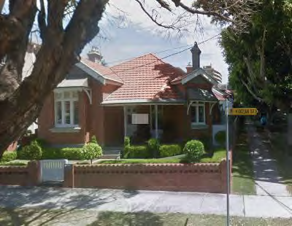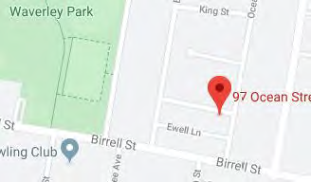
Image year |  | Image by | Google Maps | Image copyright holder

Image caption | 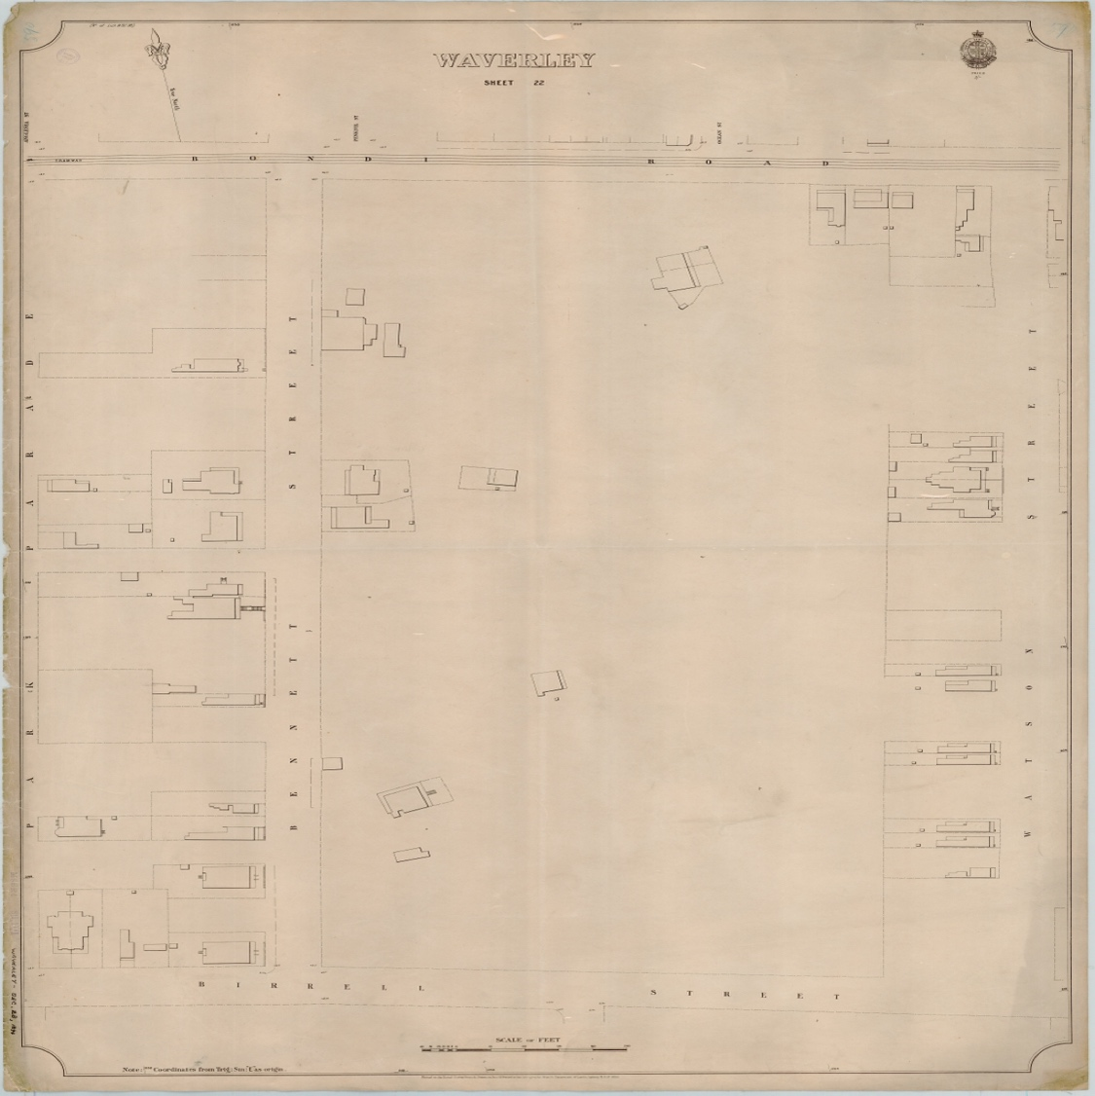
Image year | 1894 | Image by | State Library of New South Wales | Image copyright holder

Image caption | 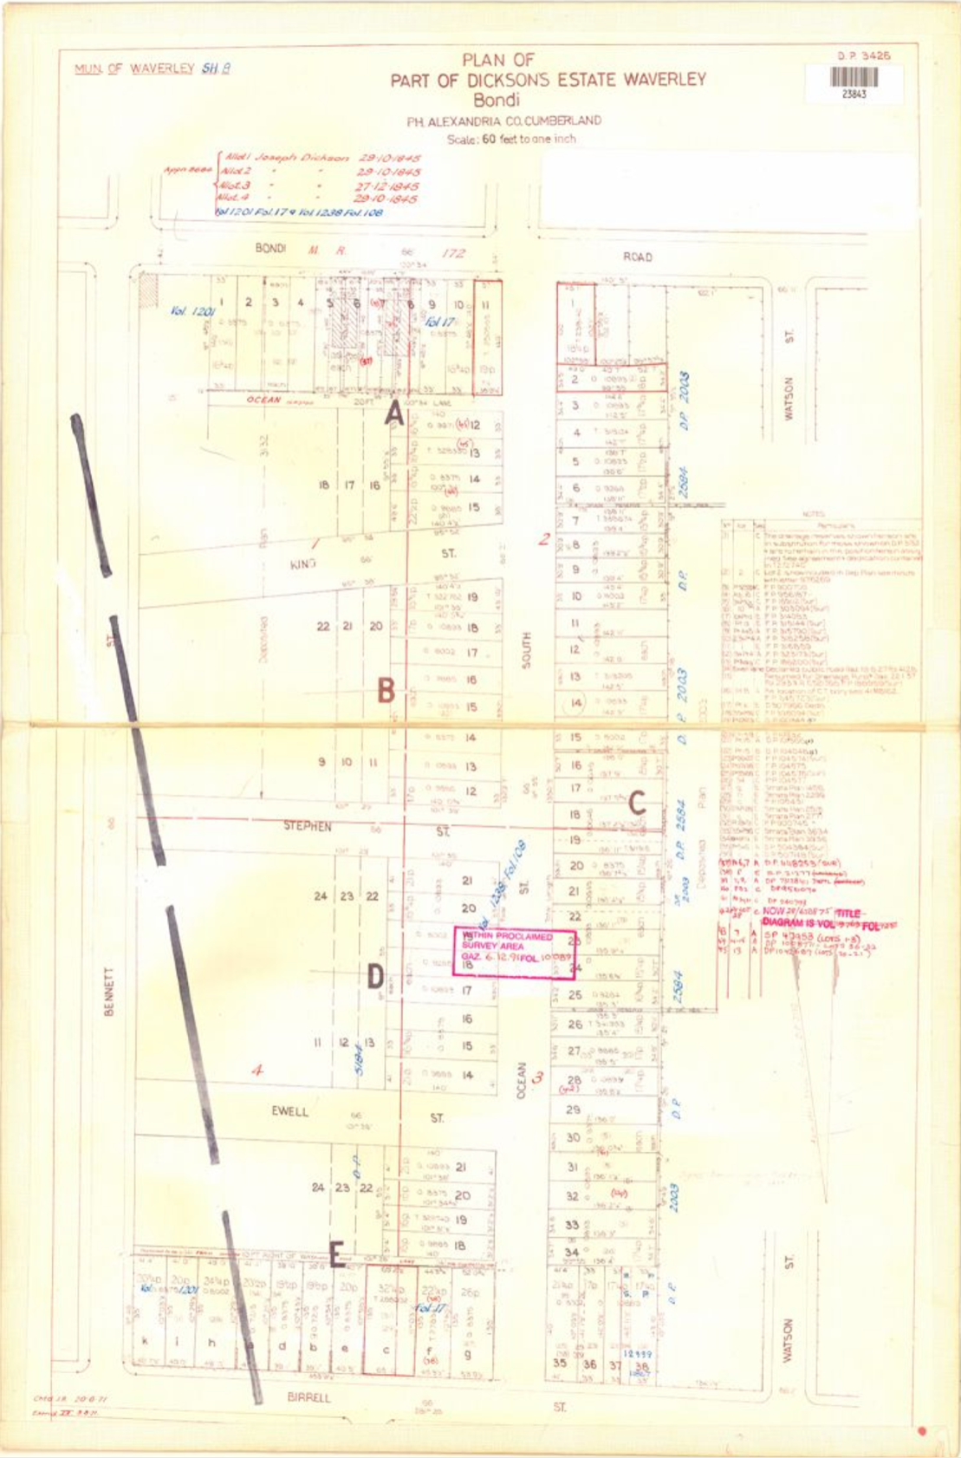
Image year | Undated | Image by | LPI | Image copyright holder

Image caption | 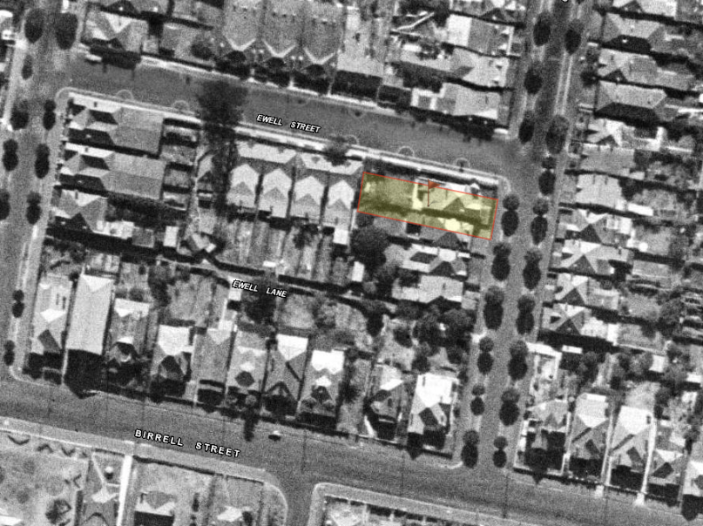
Image year | 1943 | Image by | SIX Maps | Image copyright holder

Primary Application 8684
Certificate of Title Vol 1238 Fol 108
Certificate of Title Vol 1678 Fol 46
Certificate of Title Vol 7467 Fol 181

